# **­­­Chapter 1 THE PROBLEM AND ITS SETTING**

**Introduction**

Universities needs to cope to the drastic changes, not only in terms of information technology but also in terms of determining the students’ preferences, particularly in university events. University event helps the students nurture and improve their social skills, and also helps them to improve a certain part of their attitude or skill depending on what kind of event they are attending to.

That is why the researcher comes up with an idea that will improve the current practice of universities nowadays. Event creation and publication of universities mostly relies on social media, if not on their own website. Also, it’s hard to say that each event is interesting, unless their something in the event that is worth going for, or something that will catch the interest of the many, or your target students.

The idea of creating an events portal web application exclusive only for local universities around metro manila will unify the students around it. Also, it will have them to take the opportunity to explore beyond the boundaries of their own university. With this, by taking part to the events of other universities, not only they’ve enjoyed themselves but also, they helped the university to improve its social status and credibility.

For the university event administrator, the web application’s innovation in terms of decision-support will come by analyzing the event management style of different universities near them, providing them the idea of how to create an effective and interesting event for the students near them. The analyzation of data will be optimized by a certain metadata search approach algorithm.

The purpose of this study is to help the students to find their own ideal events to go, and for the universities to help them create more effective and interesting events for the students around them. By analyzing the theoretical frame.meworks, reviewing other related studies and literatures, using questionnaires, formulating conclusions and recommendations, and by developing the web application, this study will not only help the students and universities to be more updated and informative, but also to those other related bodies to use this as their future reference for their own future planning considerations.

## **Theoretical Framework**

### **Uses and Gratification Theory**

Figure 1. Uses and Gratification Paradigm

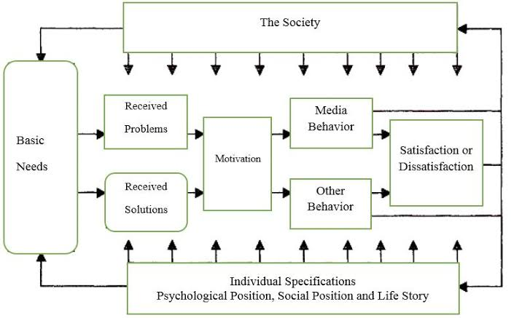

This theory seeks to comprehend why people pursue media and for what particular reason they will use it for. This theory determines the way of the individuals on how they intentionally pursue media to satisfy certain needs or wants. In terms of using web services, it is proven that it has many uses and gratifications attached to them. Due to its nature of mobility and accessibility, continuous access, and options to both add and access content, this ground of gratification is increasing with the formulation of new researches, inspired by using web application services through the internet.

This theory greatly supports the research as it helps determined the gratification of the users in terms ofefficient retrieval and access of information resources and services, assuming that the main uses and gratification of using computers to access web application services through the internet to gain high quality information resources and services.

## **Conceptual Framework**

Figure 2. The Conceptual Framework

Feedback

1.Related literature and studies about Events Portal Systems, Executive DSS, and Metadata Algorithm like articles.

2. Respondents’ response from the survey.

3. Use of theories and models to support the study.

1. Apply statistical treatment and analyze data gathered from the questionnaires.

2. Analyze the gathered information from related literature and studies.

3. Development of the UEPS-EDSS Web Application.

1. Conclusion and Recommendation of the study.

2. User’s Evaluation on the UEPS-DSS Web Application.

3. Finished and Revised UEPS-DSS Application.

**INPUT**

**PROCESS**

**OUTPUT**

In conceptual framework of the study, it gives a more visualized and well-presented idea. It also gives the flow of an input, process, and output, as it is presented in the figure.

The input presents the related literature and studies about the concepts of Events Portal Systems, Executive DSS, and Metadata related algorithms.

Input also presented the problem that needs to be solved, application of the theoretical framework for the research’s reliability and credibility, and the use of questionnaires for gathering data from the respondents.

The process presents the analyzation of the collected data from citations and studies to apply in the later part of the research, and also to utilize the used of questionnaires, conducted surveys, statistical treatment and analysis of its data.

The output presents the formulated solutions and conclusions after undergoing the said process and the development of the said web application.

## **Statement of the Problem**

The main objective of this study is to develop a web application system, sought to determine the solution for the problems faced by the students and universities, aiming to help them to satisfy the needs in terms of accessibility, management, and decisioning. Specifically, the study seeks to answer the following issues:

1. What is the level of accessibility of the respondents in terms of accessing the details of open university events around metro manila, in terms of:
   1. Venue
   2. Affordability
   3. Notification
   4. Level of Interest
2. What is the current evaluation of the universities in terms of events management, in terms of:

2.1 Creation of events;

2.2 Management;

3. What are the current factors that affects the universities in terms of event management, in terms of:

3.1 Creation of events;

3.2 Management;

3.3 Decision Making;

3.4. Event Publication;

4. What is the overall assessment and acceptance level of the respondents in terms of using the proposed system, in terms of:

4.1 Performance

4.2 Information Feedback

4.3 User-Interface

## **Scope and Limitation**

The main focus of the project is to develop a web system that will cater an events portal for students and will provide a dashboard and comprehensive reporting capabilities for the event administrator of the university. This web-based application will be using native PHP, and will use MySQL as their database.

### **Limitations**

The main features of the web-based admin side of the system is only intended for the management, and the configuration of entities that will be used in the system, and also, the decision-support feature that monitors the performance of event publication of each registered universities in the system, which can be seen through admin dashboard analytics.

Events portal is also one of the main features, that will allow the students around metro manila to view the nearby and interesting open-university events for them. Other functionalities may be added in the future if necessary.

The algorithm that will be used is based on the Metadata search approach. It will be utilized for the system’s event recommendation feature in the portal and for the decision-support dashboard analytics.

## **Significance of the Study**

This study determines the respondents’ assessment and preferences in accessing nearby university events, and to determine the management style and decision making of the universities in terms of event creation and publication, therefore, will be deemed important to the following:

**To the Local students**, as this study gives them the ability and ease in terms of accessing the events near them through portal by using the web application’s services.

**To the Universities**, as this study will help them in terms of events management and decision making, in terms of creating interesting events for all students and to improve its publication, providing universities the chance to be explored by other students from other universities.

**To the Future Researchers**, as this study helps other researchers in the same topic of conducting a study about events web portal, management, decision-support and the development of web applications relating to this, as it serves as a resource and reference for the future researchers.

## **Definition of Terms**

**Algorithm.** A procedure or set of instructions that is strictly to be followed in calculations or other problem-solving operations, especially by an electronic device, like computer.